**Prayer of Thanksgiving and Lord’s Prayer**

**All: Our Father who art in heaven, hallowed be thy name. Thy kingdom come, thy will be done, on earth as it is in heaven. Give us this day our daily bread and forgive us our debts, as we forgive our debtors; and lead us not into temptation but deliver us from evil. For thine is the kingdom and the power and the glory, forever. Amen.**

**Words of Institution**

**Distribution of the Communion Elements** *(Everyone please hold on to the elements until everyone is served and then partake when Rev. Gardner says:)*

Leader: The body of Christ given for you. (The blood of Christ shed for you.)

**All: Thanks be to God. (Or Amen.)**

**Prayer After Communion**

**\*Closing Hymn 376** “Love Divine, All Loves Excelling” *(verses 1 + 4)*

**\*Charge and Benediction**

**Postlude** LuYang Liu

**Recent Prayer Requests**

We pray for Theodosia Ashie and her family, who just lost Theodosia's mother; for the family of Betty Zwicky, the family of Doug Clausen, Janet Schott and her family, The Miller family who just lost Russ’ mom, Alice Miller; and the following as they grieve: the families of Ross Charnock, Emily Sena, Judy Walsh, Rob and Roseanne Lindemann. We pray for Eyad and Kristina Khalifeh and Raine Grace Khalifeh, Jillian Knetchtel’s mother, Susanne Stamm, Mary Jankowski, Bill Murphy, Linda’s uncle, the Herrlich family, Ellie Kramps, Betty Gustafson, Liz Henderson, Betty Sharrett, Jeannie, friend of MaryAnn Miller; Jim Tway, Rev. Charlie and Mary Sutton, the people in countries at war. If there are matters of concern or thanksgiving you would like included in our prayers or if you would like a name removed from the list, please fill out the prayer request portion of the connection card and put them into the offering or contact Lindsay at Fanwoodpres@gmail.com.

A Service for the Worship of God 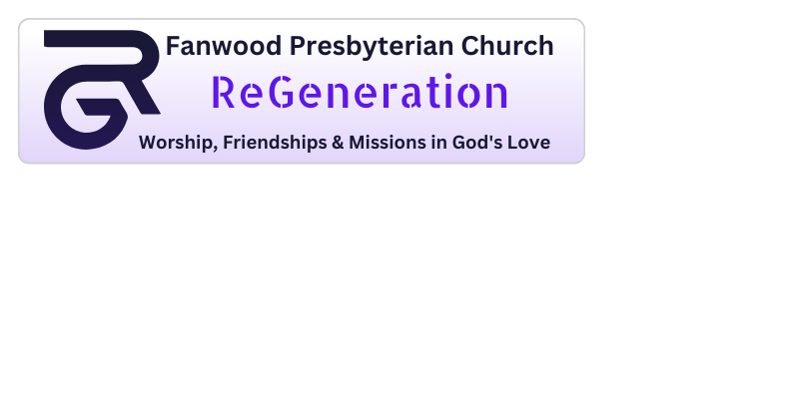

10:30 a.m. *20th Sunday after Pentecost*October 6, 2024

**Gathering Around God’s Word**

**Prelude** LuYang Liu

**Greetings and Welcome**

Leader: The gifts of the Holy Spirit be with you all.

**People: And also with you.**

*(A special welcome to our guest preacher Reverend Shelley S. Gardner.)*

**Call to Worship**

Leader: People of God, let us gather to worship and praise God’s name.

**People: I give thanks to you, O God, with my whole heart. I will glorify your name forever!**

Leader: For great is your steadfast love for me.

**People: You have delivered my soul from the depths.**

Leader: God says, “Know that I am with you and will keep you wherever you go.”

**Opening Prayer**

God who knows us completely, who knows our words before we even have a chance to speak, wrap us in your presence. Still the distractions that well up in us. Search us, know us, and guide us to the wisdom you would have us hear today. **Amen.**

**\*Opening Hymn 483** “Sing Praise to God Who Reigns Above” *(verses 1 + 4)*

**\*Call to Confession**

Sisters and brothers, all who are led by the Spirit of God are children of God. We did not receive a spirit of slavery to fall back into fear, but we received a spirit of adoption. Let us then confess our sin with the freedom of children who know how deeply they are loved.

**\*Prayer of Confession**

Merciful God, your creatures cry-creation groans - but we turn away; we surround ourselves with noise. We are quick to excuse ourselves from responsibility: we are young; we are old; we are tired; we are busy. It is hard to imagine that we might make a difference.

*(continued on next page)*

Life-giving God, wash us clean. Restore our imaginations and our hearts. Let your courage and compassion flow through our veins until we love you with abandon and our hands reach out in blessing, for the creation waits with eager longing for the revealing of the children of God. Amen.

**\*Silent Prayer of Confession**

**\*Declaration of Forgiveness**

The mercy of the Lord is from everlasting to everlasting. I declare to you, in the name of Jesus Christ, we are forgiven. Amen.

**Kyrie**

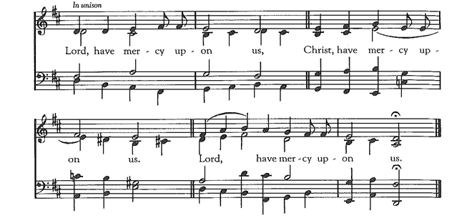

**\*Passing of the Peace**

Greeting: The peace of Christ be with you!

**Response: And also with you!**

**Announcements**

**Hearing God’s Word**

**Children’s Message** *(Children will remain for Baptism.)* Rev. Shelley S. Gardner

**Sacrament of Baptism**

Lucas David Spicer, Son of Paul and Karen Spicer

**The Apostles’ Creed**

I believe in God, the Father Almighty, Maker of heaven and earth, and in Jesus Christ, His only Son, our Lord, who was conceived by the Holy Ghost, born of the Virgin Mary, suffered under Pontius Pilate, was crucified, dead, and buried; He descended into hell; the third day He rose again from the dead; He ascended into heaven, and sitteth at the right hand of God, the Father Almighty; from thence He shall come to judge the quick and the dead. I believe in the Holy Ghost, the holy catholic Church, the communion of saints, the forgiveness of sins, the resurrection of the body, and life everlasting. Amen.

**Hymn 540** “God Be with You Till We Meet Again” *(verses 1-3)*

**Prayer For Illumination**

Holy One, you love with a Father’s tenderness, a mother’s zeal. Move now in our hearts. Breathe through the words we hear, the songs we share the burdens we carry, until we discover our purpose in your liberating love, for we long to join creation’s praise and to shine with the mercy of the Christ, in whose name we pray.

**First Lesson** Genesis 28: 10-19

**Second Lesson** Psalm 139: 1-12, 23-24

**Message** “Wherever You Go” Rev. Shelley S. Gardner

**Responding to God’s Word**

**Offering**

**Offertory Music** “Be Thou My Vision” Lindsay Fisher Jenkins

**\*Doxology 592**

**\*Prayer of Dedication**

**\*Hymn 505** “Be Known to Us in Breaking Bread”

**The Sacrament of the Lord’s Supper**

**Invitation**